# CREATING A RESOURCES GROUP USING A PUBLIC CLOUD SERVICE PROVIDER (AZURE)

**STEP – 1:**

Create a new resource group.

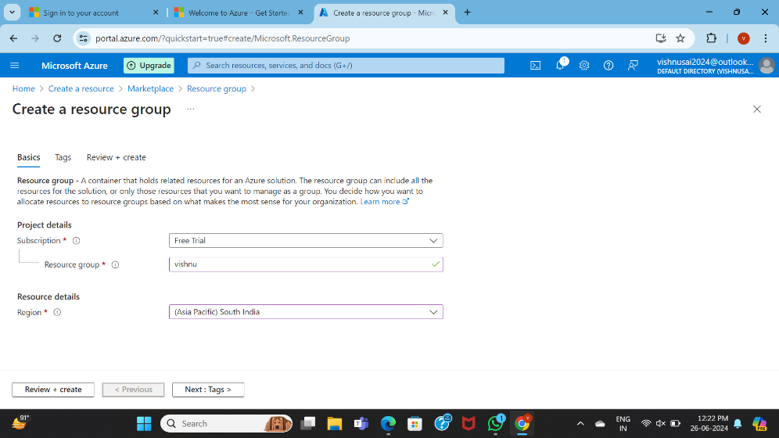

**STEP – 2:**completion od basis form

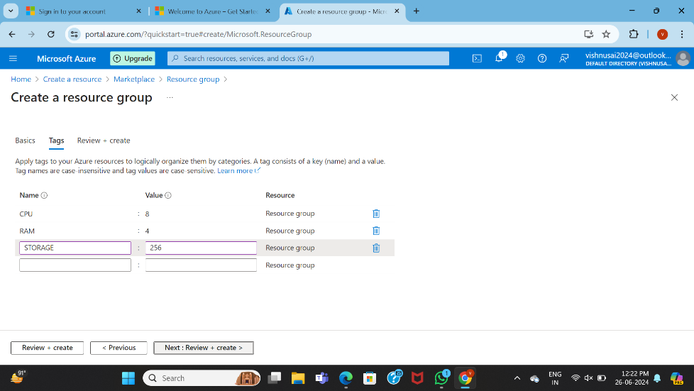

**STEP – 3:**

Fill upon the tags form.

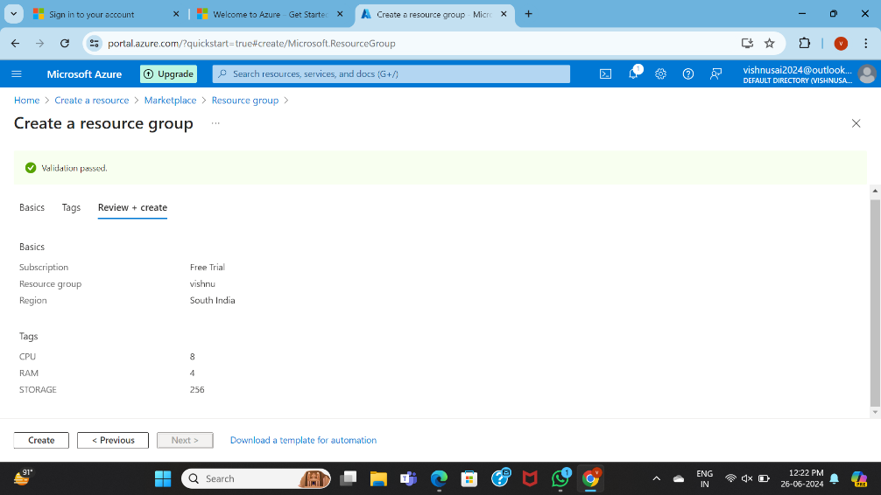

**STEP – 4:**

Review the given details of your requirements.

